**OUR GOALS FOR STUDENT Achievement 2021-2022 (Draft)**

**Reading**

The reading proficiency rate for students who score as "approaches grade level" will increase by 15% for all students on STAAR by focusing on improved Tier 1 instruction.

**Math**

The math proficiency rate for students who score as "approaches grade level" will increase by 10% for all students on STAAR by focusing on targeted instructions using the formative assessment model and data driven instruction.

**Behavior**

The total count of school wide discipline referrals will decrease by approximately 37% through Positive Behavior Interventions & Support (PBIS) practices.

**Attendance**

By June 2021, we will increase our student attendance to a daily average of 97% through student and family engagement.

***Students, Teachers, Parents – Working together for success!***

**Kindergarten students**

* I will participate actively in daily lessons.
* I will respect my teachers and all other adults in the building through my words and actions.
* I promise to always try my very best!
* I will be a friend to those in need.

**In the kindergarten classroom**

* Create a supportive and effective learning environment for each student.
* Build a meaningful, interactive teacher/student/parent relationship.
* Monitor students’ progress through on-going assessments and offer intervention, in each grade level, for struggling students.
* Provide a highly qualified teacher that develops the academic, emotional, psychological and physical well-being of the child.

**AT HOME**

* Read with child for at least 15 minutes each night to promote language development.
* Ensure that homework assignments are complete.
* Celebrate the success of the child in all areas of school performance.
* Visit free educational website starfall.com to continue learning at home.



2021-2022 (DRAFT)

**KINDERGARTEN**

SCHOOL-PARENT COMPACT

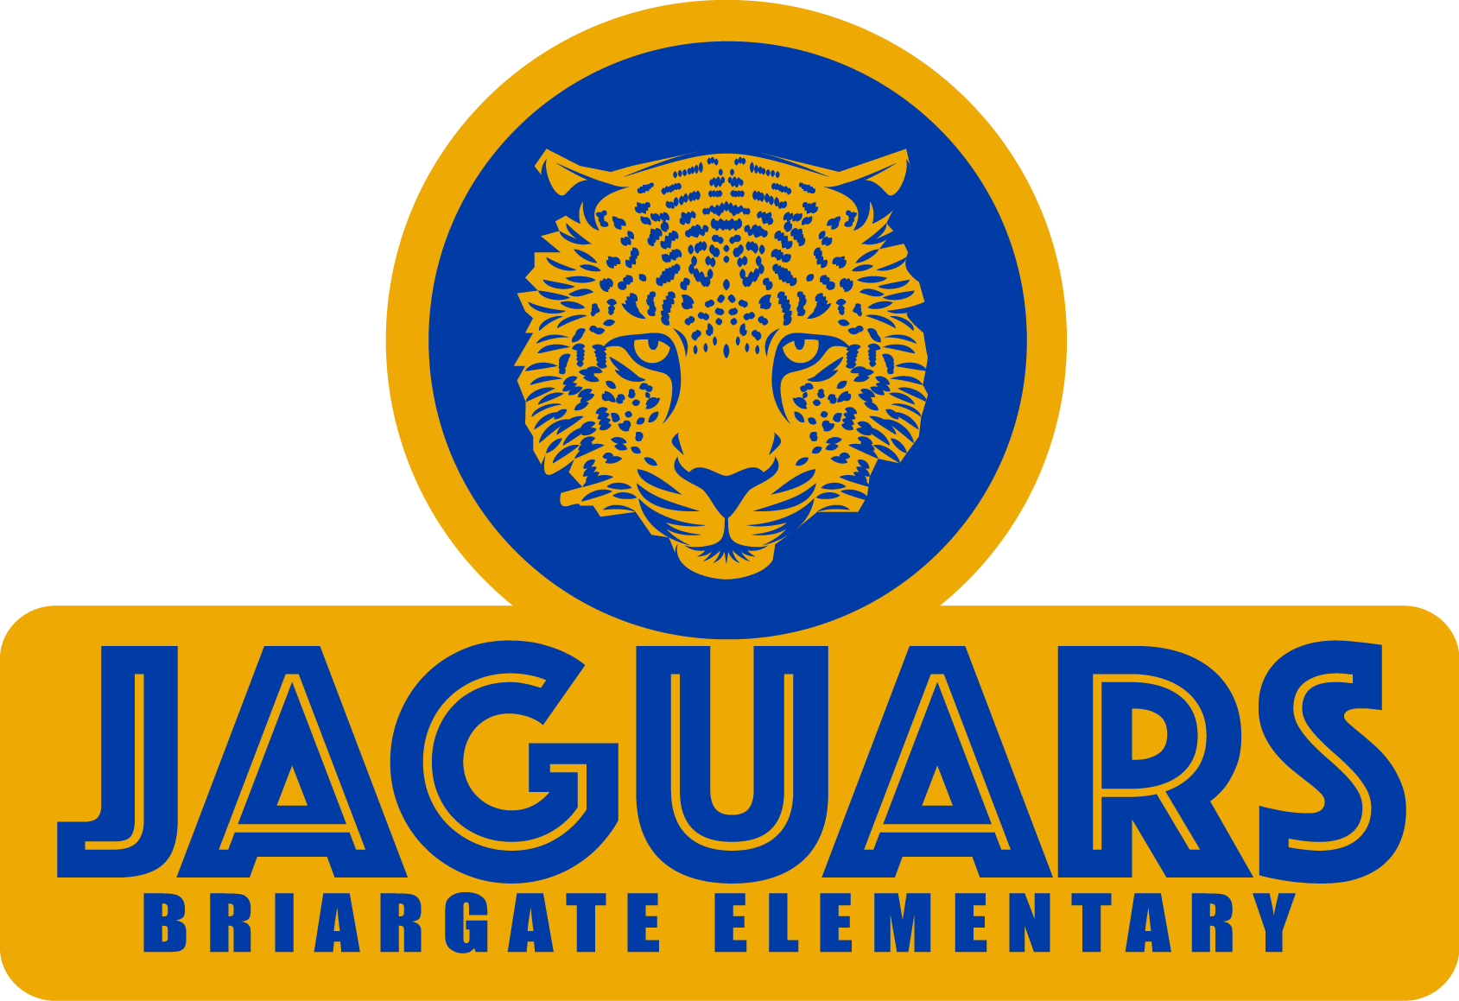

*Be Safe.*

*Be Responsible.*

*Be Respectful.*

**Principal** – Dr. Latoya Garrett

**Assistant Principal** – Kimsheka Bowie

15817 Blue Ridge Rd.

Missouri City, TX 77489

(281) 634-4560

www.fortbendisd.com/bge

**WHAT IS A SCHOOL-PARENT COMPACT?**

Effective schools are a result of families and school staff working together to ensure that children are successful in school. A compact is a voluntary agreement between two groups that firmly unites them. You are invited to be involved in a partnership with Briargate Elementary.

**Jointly DEVELOPED WITH PARENTS**

The parents, students, and staff of Briargate Elementary School will meet yearly to discuss student-learning needs based on current grade-level data. Our School-Parent Compact for Achievement will be revised based on these discussions. Teachers suggest home learning strategies, parents add ideas to make them more specific, and students identify ways to support their learning goals.

*Parents are welcome to contribute comments at any time.*

**Building partnerships**

**Volunteer Information:**

VIPS Coordinator – Tyenise Blackmon

[tyenise.blackmon@fortbendisd.com](mailto:tyenise.blackmon@fortbendisd.com)

**Parent Workshops/Events Information:**

Parent Educator- Charlene Spicer-Harmon

[Charlene.SpicerHarmo@fortbendisd.com](mailto:Charlene.SpicerHarmo@fortbendisd.com) (281) 634-7759

**ACTIVITIES TO BUILD PARTNERSHIPS**

There are many opportunities at our school for parents to volunteer and play a role in their child’s education. Please consider joining the faculty, staff, and fellow parents through some of the following events and programs:

* Open House
* Volunteer for Field Day
* Literacy, Math, and Science Nights
* Special Visitor’s Day such as Donuts with Dads, Muffins with Mom, and Veterans Day
* Parent Workshops: day/night time meetings to increase parent capacity on varied topics
* One Saturday morning event
* At least 2 virtual events

**COMMUNICATION ABOUT LEARNING**

Briargate Elementary is committed to frequent two -way communication with families about children’s learning. Some of the ways you can expect us to reach you are:

• Weekly homework folders

• Current grades available through Skyward/Family Access

• Electronic Marquee will display upcoming school events and school information.

• Progress reports 3 times a year and report cards once per quarter

• Call-Outs and emails regarding school events and school information